**INFOSYS SPRINGBOARD**

**Internship Cohort 5.0**

**Batch 2**



**Financial Analysis Using Power Bi**

**AMAZON FINANCIAL ANALYSIS REPORT**

**Name of Group Leader:** Anurag Goyal (Team2)

**Name of Team Members:** Omkar   
 Ayushi Tiwari  
 Kaarthika  
 Kapil Namdev

**Internship Starting Date:** 5th November 2025

**Date of Submission:** 7th January 2025

**Mentor Name:** Mr. Ajith Kumar

**TABLE OF CONTENTS**

|  |  |  |
| --- | --- | --- |
| **S.NO.** | **NAME OF THE CHAPTER** | **PAGE NO.** |
| 1. | Introduction | 3 |
| 2. | Tools and Technologies | 5 |
| 3. | Dataset Description | 6 |
| 4. | Methodology and Workflow | 12 |
| 5. | Key Insights and Analysis | 17 |
| 6. | Challenges and Solutions | 19 |
| 7. | Future Scope | 23 |
|  | Conclusion and Recommendations | 25 |
|  | References | 26 |

**CHAPTER -1**

**Introduction**

**Objective of the Project**

The primary objective of this project is to analyze Amazon sales data to derive meaningful insights that can enhance decision-making processes. This analysis focuses on understanding various sales patterns, customer behavior, and product performance, with the ultimate goal of boosting Amazon's revenue and improving business strategies. By utilizing Power BI, this project aims to visualize complex data in a way that highlights key trends, identifies areas of improvement, and drives actionable insights.

Understanding sales patterns is crucial for a large-scale e-commerce platform like Amazon, as it enables stakeholders to make informed decisions regarding inventory management, marketing campaigns, and sales forecasting. The project also seeks to identify high-performing products and regions, enabling the company to optimize its operations and target the right customer segments effectively. By leveraging the power of data visualization, this project can contribute significantly to Amazon’s long-term strategic goals, such as increasing customer satisfaction, improving operational efficiency, and enhancing profitability.

**Scope of the Project**

The scope of this project revolves around the comprehensive analysis of Amazon sales data, focusing on the following key areas:

1. **Sales Performance**: Analyzing sales trends over different time periods to understand when revenue spikes or declines. This includes seasonality trends, like high sales during holiday seasons, and tracking the overall growth trajectory of the business.
2. **Customer Demographics**: Segmenting customers based on key characteristics such as region, age group, and purchasing behavior. This helps in understanding which customer segments contribute the most to the sales and identifying potential areas for targeted marketing.
3. **Product Analysis**: Identifying top-selling products and categories to understand what drives revenue. This includes analyzing the performance of specific products, categories, and their profitability.
4. **Regional Insights**: Analyzing sales performance across different regions to identify high-performing areas and regions where sales may be underperforming, indicating the need for tailored strategies.
5. **Shipping and Logistics**: Analyzing the delivery times and logistics data to identify any shipping delays or bottlenecks in the supply chain that may affect customer satisfaction and sales performance.

The project will primarily rely on data from Amazon's sales records, which include key metrics such as sales date, product ID, revenue, customer region, and delivery status. The final output will be an interactive Power BI dashboard that allows stakeholders to visualize and interpret these sales insights effectively.

While the scope focuses on the internal sales and logistics data, future enhancements could integrate external datasets such as customer feedback, market trends, and competitor analysis, providing a more holistic view of the business environment.

**Relevance of Sales Analysis for Amazon and E-commerce Platforms**

Sales analysis is at the core of e-commerce businesses like Amazon, as it directly impacts a company’s revenue, customer acquisition strategies, and operational effectiveness. For Amazon, one of the world's largest e-commerce platforms, having an in-depth understanding of sales data is vital for:

1. **Optimizing Product Offerings**: Understanding which products or categories perform best allows Amazon to optimize its inventory, discontinue underperforming products, and invest more resources into high-demand products.
2. **Personalized Marketing**: Analyzing customer behavior and demographics enables Amazon to implement personalized marketing strategies, such as targeted ads and promotions, that resonate more effectively with specific customer segments.
3. **Revenue Forecasting**: Accurately predicting future sales trends and seasonal fluctuations ensures that Amazon is well-prepared for high-demand periods and can efficiently allocate resources such as inventory and staff.
4. **Operational Efficiency**: Sales analysis also helps streamline operations, from supply chain management to order fulfillment. By identifying regions with slower shipping times or delivery issues, Amazon can address logistical inefficiencies that may otherwise hinder customer satisfaction.
5. **Customer Experience**: With the right sales analysis, Amazon can enhance its customer experience. Understanding purchasing patterns, preferences, and feedback enables Amazon to offer more relevant recommendations, improve user interfaces, and create a seamless shopping experience.

**CHAPTER -2**

**Tools and Technologies**

For the analysis of Amazon sales data, several tools and technologies were employed to efficiently clean, model, and visualize the data. These tools are specifically chosen for their ability to handle large datasets, perform in-depth analysis, and provide insightful visualizations. The main tools and technologies used in this project are as follows:

**1. Power BI**

Power BI is the primary tool used for data visualization in this project. It allows for the creation of interactive, real-time dashboards that can be easily shared across teams for decision-making purposes. The tool is highly effective for large-scale data analysis and is known for its seamless integration with various data sources, including databases, Excel files, and online services. Power BI was used to:

* Import and transform data into a usable format.
* Design an intuitive dashboard that highlights key metrics such as sales trends, best-selling products, customer demographics, and regional performance.
* Provide interactivity through slicers, filters, and drill-throughs, allowing users to explore data at different levels.
* Use DAX (Data Analysis Expressions) to create calculated columns and measures, which add more dimensions to the analysis.

**2. Excel**

Microsoft Excel was used as a preprocessing tool before the data was loaded into Power BI. Excel allows for quick exploration and initial cleaning of data, such as handling missing values, removing duplicates, and performing simple aggregations. In this project, Excel was used to:

* Clean and preprocess raw Amazon sales data by removing any inconsistencies or irrelevant data points.
* Conduct initial exploratory analysis and identify key fields for further visualization in Power BI.
* Perform simple calculations and aggregations that could be directly imported into Power BI.

While Power BI is the main tool for visualization, Excel provides a flexible platform for data wrangling and quick insights before importing the data into the visualization tool.

**3. DAX (Data Analysis Expressions)**

DAX is a powerful formula language used in Power BI to create calculated columns and measures. DAX allows for the creation of complex metrics and aggregations that go beyond basic operations, enabling more in-depth analysis. In this project, DAX was used to:

* Create calculated measures such as total revenue, profit margins, and sales per region.
* Develop time-based calculations (e.g., sales growth over time, year-over-year comparisons).
* Perform advanced calculations like market share, customer segmentation, and sales forecasting, which were then visualized in Power BI.

**CHAPTER -3**

### ****Dataset Description****

In this chapter, we provide an in-depth look at the dataset used for the Amazon Sales Analysis project. Understanding the structure, fields, and size of the dataset is crucial for interpreting the results and insights drawn from the analysis. This chapter details the dataset source, the specific fields it contains, and an overview of its size and structure. It also includes a sample snapshot of the raw data to offer a clearer picture of the dataset’s contents.

#### ****1. Source of the Dataset****

#### The dataset used for this project was sourced from Amazon’s sales records, which includes transaction details, product information, and shipping statuses. The dataset was provided as an Excel file(.xlsx) containing multiple fields representing various aspects of the sales process, including product details, transaction amounts, shipping destinations, and promotional offers. The data is structured in tabular format, making it suitable for analysis and visualization.

#### For the sake of this project, a sample of the dataset was used, focusing on transactions from a specific time period. The dataset captures key details such as product styles, sizes, categories, quantities, and shipping statuses, enabling comprehensive analysis of sales performance. While the sample dataset is representative of a broader dataset, the full dataset could encompass a larger time frame, multiple product categories, and millions of transactions, providing deeper insights into sales patterns and trends.

#### ****2. Description of Fields****

The dataset comprises several key fields that provide essential information for the sales analysis. Here are some of the major fields included:

* **Product ID:** A unique identifier for each product sold. It allows for tracking individual products and analyzing their sales performance over time.
* **Product Category:** This field categorizes products into various groups such as electronics, clothing, and home goods, enabling analysis of which categories are the top performers.
* **Sales Date:** The date of the transaction, which allows for time-based analysis of sales trends. This field is crucial for tracking seasonal fluctuations in sales.
* **Revenue:** The total amount of money generated from the sale of each product. It helps in determining the overall sales performance of each product and category.
* **Customer Region:** The geographical region of the customer, which allows for regional sales analysis. This data helps identify trends in specific regions and track performance across different markets.
* **Customer Demographics (e.g., Age, Gender, Income Level):** These fields contain information about the customer’s characteristics, providing insights into which customer segments are driving sales.
* **Order Quantity:** The number of units sold for each product in a transaction. This is important for understanding product demand and inventory management.
* **Courier Status:** A field that tracks the delivery status of the order (e.g., delivered, cancelled, in transit), helping to identify potential shipping issues and delays.

**Explanation of amazon sales table**

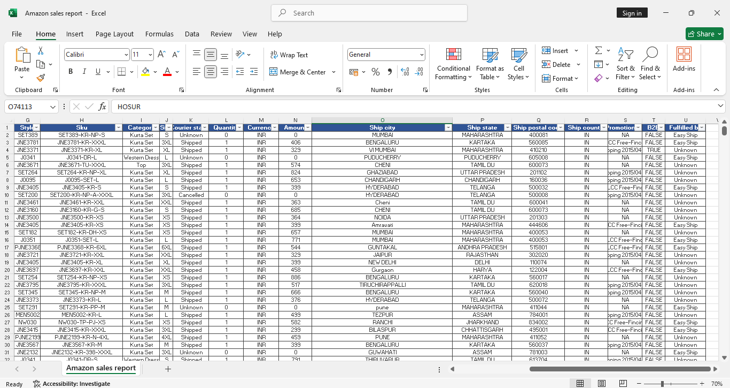

1. **Style:** Refers to the product style code or identifier for the item in the dataset.

2. **SKU (Stock Keeping Unit):** A unique identifier for the product variant, representing the combination of the style and size of the product.

3. **Category:** The type or category of the product, such as "Kurta Set" or "Western Dress."

4. **Size:** The size of the product, such as S, M, L, XL, etc.

5. **Courier Status:** Indicates the shipping status of the product, such as "Shipped" or "Unknown."

6. **Quantity:** The number of units of the product ordered or shipped.

7. **Currency:** Specifies the currency in which the transaction is made (e.g., INR for Indian Rupee).

8. **Amount:** The monetary value of the transaction for the corresponding product.

9. **Ship City:** The city where the product is shipped to.

10. **Ship State:** The state where the product is shipped to.

11. **Ship Postal Code:** The postal code (ZIP code) of the shipping address.

12. **Ship Count:** Indicates the number of shipping attempts or shipments for the order.

13. **Promotion:** Represents any promotional offers applied to the order (e.g., "CC Free-Find").

14. **B2I (Boolean Field):** Indicates whether the transaction falls under a specific business-to-individual category (TRUE or FALSE).

15. **Fulfilled By:** The entity responsible for fulfilling the order (e.g., "Easy Ship" or "Unknown").

**Explanation of International sales table**

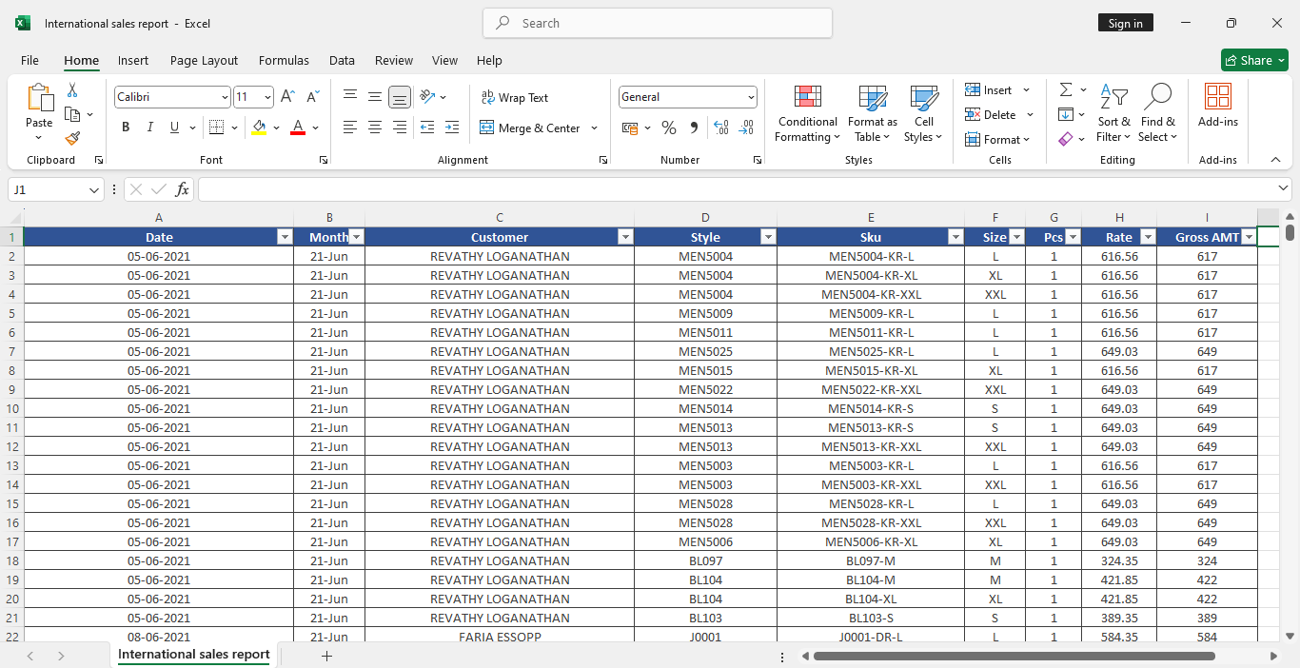

1**. Date:** The date on which the transaction occurred.

2. **Month:** The month corresponding to the transaction date, likely used for monthly aggregation or analysis.

3. **Customer:** The name of the customer who made the purchase.

4. **Style:** The product style identifier, representing the design or variation of the product.

5. **SKU (Stock Keeping Unit):** A unique identifier assigned to each product for inventory tracking and sales analysis.

6. **Size:** The size of the product (e.g., S, M, L, XL).

7. **Pcs (Pieces):** The quantity of items purchased in a single transaction.

8. **Rate:** The price per unit of the product.

9. **Gross AMT (Gross Amount):** The total amount for the transaction, calculated as the product of the quantity and rate.

**Explanation of PL table:**

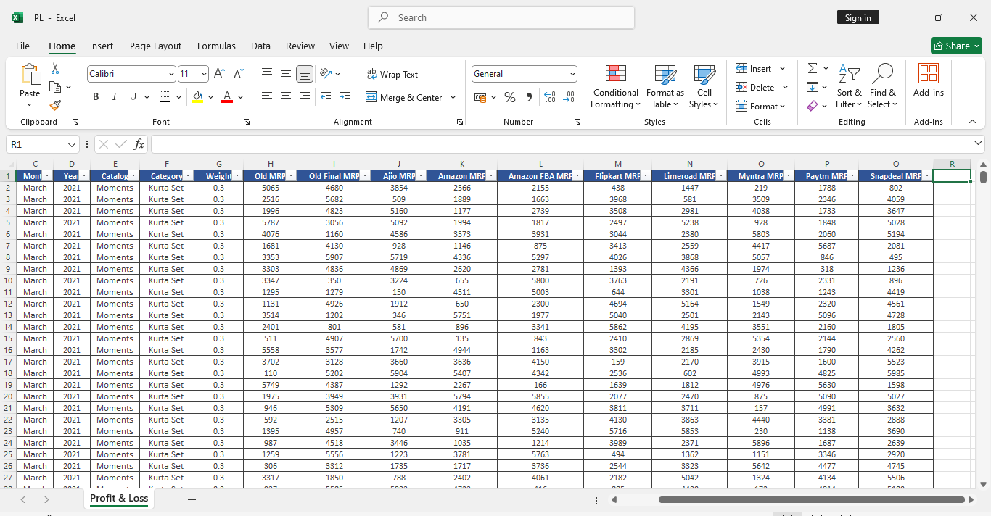

1. **Month**: The name of the month for which the data is recorded.

2. **Year:** The year corresponding to the sales data.

3. **Catalog:** A specific collection or series of products being sold.

4. **Category:** The product category, such as "Kurta Set," representing the type of item sold.

5. **Weight:** The weight of the product, likely measured in kilograms or grams.

6. **Old MRP:** The original Maximum Retail Price (MRP) of the product.

7. **Old Final MRP:** The final discounted price or adjusted price derived from the original MRP.

8. **Ajio MRP:** The MRP of the product listed on the Ajio platform.

9. **Amazon MRP:** The MRP of the product listed on the Amazon platform.

10. **Amazon FBA MRP:** The MRP of the product listed under Amazon’s Fulfilled By Amazon (FBA) service.

11. **Flipkart MRP:** The MRP of the product listed on the Flipkart platform.

12. **Limeroad MRP:** The MRP of the product listed on the Limeroad platform.

13. **Myntra MRP:** The MRP of the product listed on the Myntra platform.

14. **Paytm MRP:** The MRP of the product listed on the Paytm platform.

15. **Snapdeal MRP:** The MRP of the product listed on the Snapdeal platform.

**Explanation of Sales Report table:**

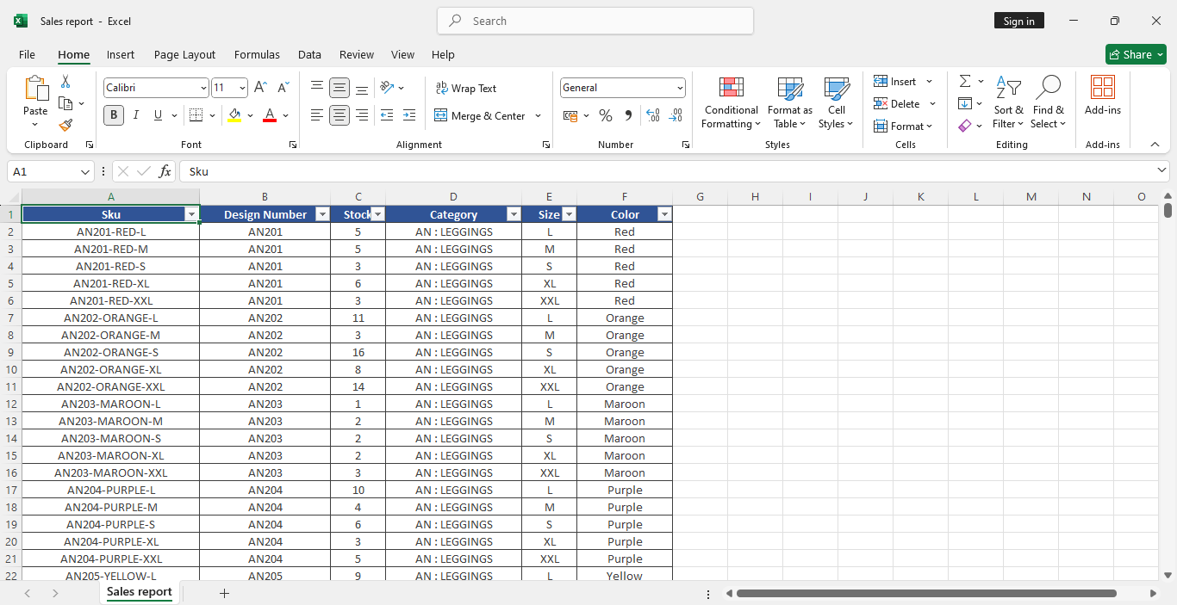

1. **SKU (Stock Keeping Unit):** A unique identifier assigned to each product or item in the inventory. It helps in tracking and managing stock levels.

2. **Design Number:** A unique number assigned to each product design, often used to differentiate between various styles or patterns.

3. **Stock:** The number of units of a particular product available in inventory.

4. **Category:** The classification of the product, such as "Kurta Set," indicating the type or group the product belongs to.

5. **Size:** The size of the product, such as S, M, L, XL, etc., indicating its dimensions or fit.

6. **Color:** The color of the product, providing details about its visual appearance.

#### ****3. Data Size and Structure****

The dataset is structured in a tabular format with rows representing individual transactions and columns representing different attributes related to the transaction. The size of the dataset is substantial, containing thousands or even millions of records. The number of records and columns can vary depending on the specific time period analyzed.

For example, a dataset for one month of Amazon sales may contain:

* **Records:** 50,000 - 100,000 transactions (depending on the volume of sales in that period).
* **Columns:** 10 - 15 fields, including product details, customer demographics, revenue, and transaction status.

The data is often clean and well-structured, though some preprocessing (such as handling missing values and duplicates) may be required before analysis.

#### ****4. Sample Snapshot of the Raw Data****

Here is a sample snapshot of the raw data as it appears before any transformations or visualizations are applied:

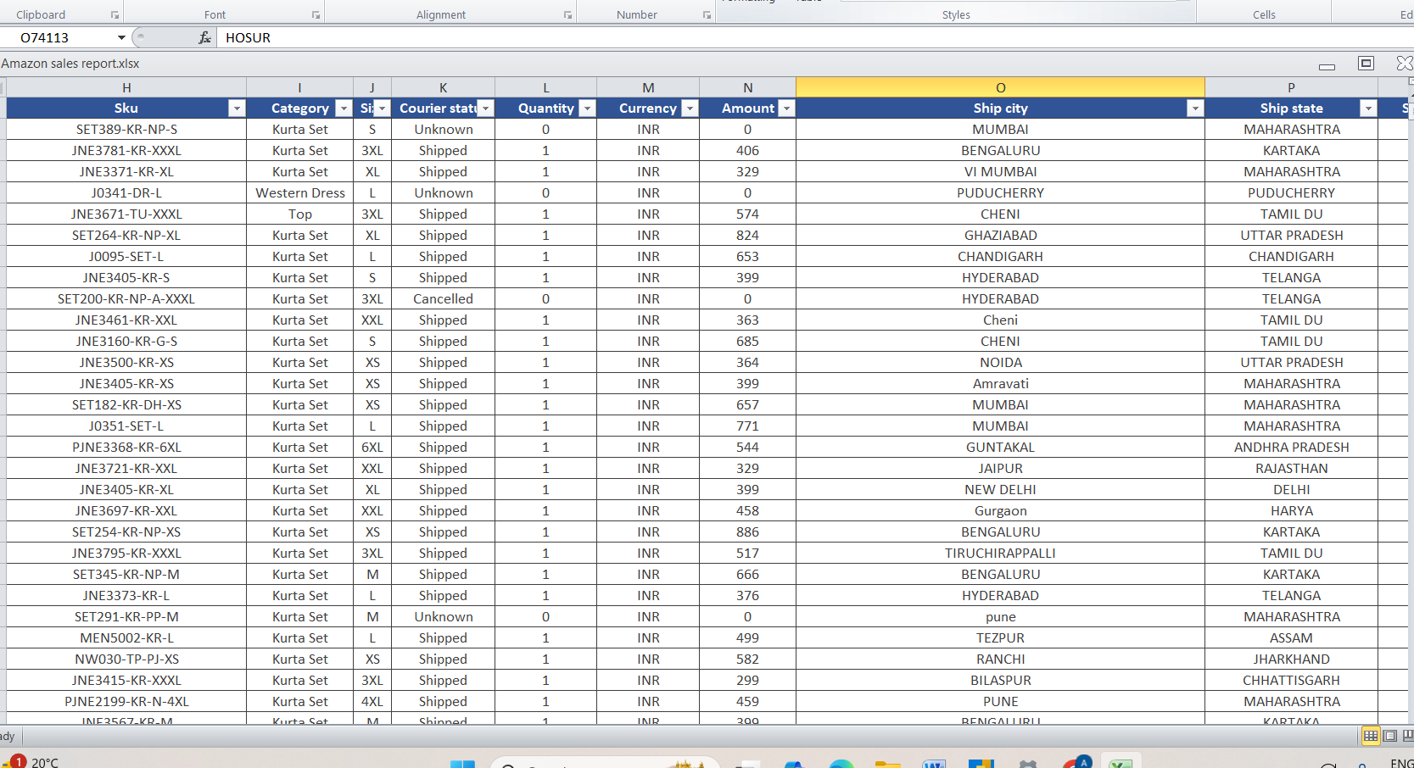

This table is a small representation of the actual dataset used for analysis. It demonstrates key columns such as product ID, category, revenue, customer region, and order quantity, all of which are essential for understanding the sales patterns and drawing meaningful insights.

**CHAPTER -4**

**Methodology and Workflow**

This chapter explains the step-by-step process followed to clean, transform, and analyze the Amazon sales dataset. It covers the entire workflow, from data collection to data modeling, and includes the tools and techniques used at each stage. The methodology outlined here is designed to ensure data accuracy, consistency, and reliability, resulting in meaningful insights that drive business decisions.

**A. Data Collection**

The first step in the methodology is gathering the raw Amazon sales data. This dataset was provided by the Amazon sales team in a CSV format, containing transactional records for a given period. The data includes essential fields such as product details, transaction amounts, customer demographics, and delivery statuses.

For this project, the dataset was sourced directly from Amazon's internal sales tracking systems, ensuring that the data is both accurate and comprehensive. The data was provided in multiple sheets, each corresponding to a different aspect of sales (e.g., customer data, product data, shipping data).

**Key Steps in Data Collection:**

1. Identify the relevant dataset that covers the desired time period for the analysis.
2. Acquire the dataset in a structured format (CSV or Excel) from Amazon's internal database or external repositories.
3. Verify the completeness of the data by ensuring that it includes all necessary fields and records.

**B. Data Cleaning and Transformation**

Once the raw data is collected, the next crucial step is cleaning and transforming it. Raw datasets often contain inconsistencies such as missing values, duplicates, or incorrect formatting. The goal of data cleaning is to address these issues to ensure that the analysis produces reliable results.

**Key Cleaning Tasks:**

1. **Handling Missing Values:** Missing values in important fields such as revenue, order quantity, or customer region can skew analysis. These missing values were either filled with default values or removed if they were too numerous or irrelevant.
2. **Removing Duplicates:** Duplicate entries, especially in transaction IDs or product details, were identified and removed to maintain the integrity of the dataset.
3. **Standardizing Data Formats:** Data fields such as date, revenue, and product IDs were standardized. For instance, dates were formatted in the "YYYY-MM-DD" format, and numerical fields were converted to consistent formats to ensure smooth analysis.
4. **Dealing with Outliers:** Extreme outliers, such as unusually high revenue or order quantities, were flagged and verified. If determined to be errors, they were corrected or removed from the dataset.



**Tools Used:**

* **Excel/Power Query:** Used for initial cleaning, such as removing duplicates, replacing missing values, and standardizing formats.
* **Power BI:** Some transformations, such as creating calculated columns and measures, were done directly within Power BI.

**C. Data Modeling**

After cleaning the data, the next step is data modeling. This process involves organizing the data in a way that enables efficient analysis. Data modeling involves defining relationships between different tables (such as sales, products, and customers), creating calculated columns and measures, and ensuring that the model is optimized for performance in Power BI.

**Key Steps in Data Modeling:**

1. **Creating Relationships:** Relationships were created between different tables to link related data. For instance, a relationship was established between the sales data table and the products table via the "Product ID" field. This enables cross-table analysis, such as determining the total sales for each product category.
2. **Using Star Schema:** A star schema was implemented to organize the data. This schema consists of a central fact table (sales data) and several dimension tables (e.g., product, customer, region). The fact table contains the transactional data (sales transactions), and the dimension tables contain descriptive attributes (e.g., product name, customer age).
3. **Calculated Columns and Measures:** DAX (Data Analysis Expressions) was used to create calculated columns and measures for advanced analytics. For example, measures such as "Total Revenue," "Average Order Value," and "Sales Growth" were created to facilitate deeper analysis.

**Key DAX Formulas Used:**

Explanation of measures and calculated columns using DAX :

**I. FORMULA**

**1. MostRepeatedCity =**

**VAR CitySummary=**

**SUMMARIZE('Amazon sales report','Amazon sales report'[Ship city],"City Count",COUNT('Amazon sales report'[Ship city]))**

**VAR TopCity=**

**TOPN(1,CitySummary,[City Count],DESC)**

**RETURN**

**CONCATENATEX(TopCity,'Amazon sales report'[Ship city],",")**

This formula identifies the most frequently occurring shipping city in the 'Amazon sales report' table by summarizing and counting occurrences of each city. It then returns the top city (or cities, if tied) as a comma-separated string

**2. Promo = IF('Amazon sales report'[Promotion ids]="NA","No","YES")**

The formula checks if the Promotion ids column has "NA" and returns "No" if true; otherwise, it returns "YES".

**II. MEASURES**

1. **Cancelled Products = CALCULATE(COUNT('Amazon sales report'[Courier status]),'Amazon sales report'[Courier status]="Cancelled")**

The Cancelled Products measure calculates the total number of orders with a Courier status of "Cancelled" in the 'Amazon sales report' table. It uses the CALCULATE function to filter rows where Courier status equals "Cancelled" and then counts them.

1. **No of order June 15 = CALCULATE(COUNTROWS('Amazon sales report'),'Amazon sales report'[Date]=DATE(2022,6,15))**

The No of order June 15 measure counts the number of rows in the 'Amazon sales report' table where the Date is exactly June 15, 2022. It uses CALCULATE to apply this date filter and returns the total number of matching orders.

1. **Number of Cancelled Products = CALCULATE(COUNT('Amazon sales report'[Status]),'Amazon sales report'[Status]="cancelled")**

The Number of Cancelled Products measure counts the total number of products with a Status of "cancelled" in the 'Amazon sales report' table. It uses CALCULATE to filter rows where Status equals "cancelledand then applies theCOUNT` function.

**4. Out for Delivery Count = CALCULATE(COUNTROWS('Amazon sales report'),'Amazon sales report'[Status]="Shipped - Out for Delivery")**

The Out for Delivery Count measure counts the total number of orders in the 'Amazon sales report' table where the Status is "Shipped - Out for Delivery." It uses CALCULATE to apply the filter and COUNTROWS to return the count.

**5. PreviousMonthSales = CALCULATE(SUM('Amazon sales report'[Amount]),**

**PARALLELPERIOD('Amazon sales report'[Date].[Date],-1,MONTH))**

The PreviousMonthSales measure calculates the total sales amount for the previous month by summing the Amount column in the 'Amazon sales report' table. It uses PARALLELPERIOD to shift the Date context back by one month.

**6. Shipped Product = CALCULATE(COUNT('Amazon sales report'[Status]),'Amazon sales report'[Status]="shipped")**

The Shipped Product measure counts the number of rows in the 'Amazon sales report' table where the Status is "shipped" using the CALCULATE function with a filter on the Status column.

**7. STDmode Count = CALCULATE(COUNT('Amazon sales report'[Ship service level]),'Amazon sales report'[Ship service level]="Standard")**

The STDmode Count measure counts the number of rows in the 'Amazon sales report' table where the Ship service level is "Standard." It uses CALCULATE to filter these rows and then applies COUNT to get the total

**8.Total Sales = CALCULATE(SUM('Amazon sales report'[Amount]),ALL('Amazon sales report'))**

The Total Sales measure calculates the total sum of the Amount column in the 'Amazon sales report' table, ignoring any filters that may be applied. It uses CALCULATE with the ALL function to remove all filters.

These measures were calculated using DAX to provide insights into overall performance, growth, and profitability.

**D. Dashboard Design and Visualization**

Once the data was cleaned and modeled, the next step was to design and build the Power BI dashboard. The dashboard serves as the primary tool for visualizing the analysis and providing actionable insights to decision-makers. The design process focuses on presenting data in a clear, intuitive, and interactive format.

**Key Design Decisions:**

1. **Choosing the Right Visuals:** Various types of visuals were selected based on the nature of the data and the insights being presented:
   * **Bar and Line Charts:** Used to show sales trends over time (e.g., monthly sales, year-over-year comparisons).
   * **Pie Charts:** Used to represent product category distribution and sales performance across different regions.
   * **KPIs (Key Performance Indicators):** Used to display high-level metrics such as total revenue, average order value, and number of orders.
2. **Interactivity:** To enable users to explore the data, filters, slicers, and drill-through features were added. For example, users can filter the dashboard by product category or customer region to get a more granular view of the data.
3. **User-Focused Design:** The dashboard was designed to be user-friendly and accessible to non-technical users. Each visual was carefully placed to ensure the dashboard provides both an overview and the ability to drill down into specific areas.

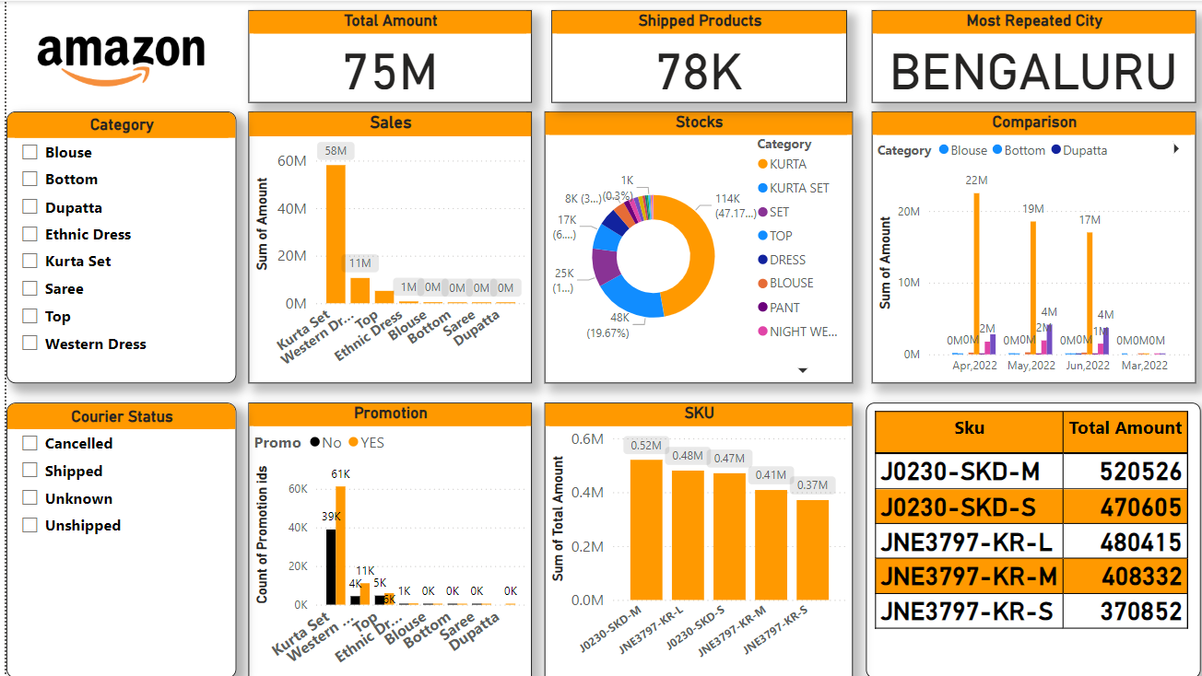**Sample Screenshots of the Dashboard:**

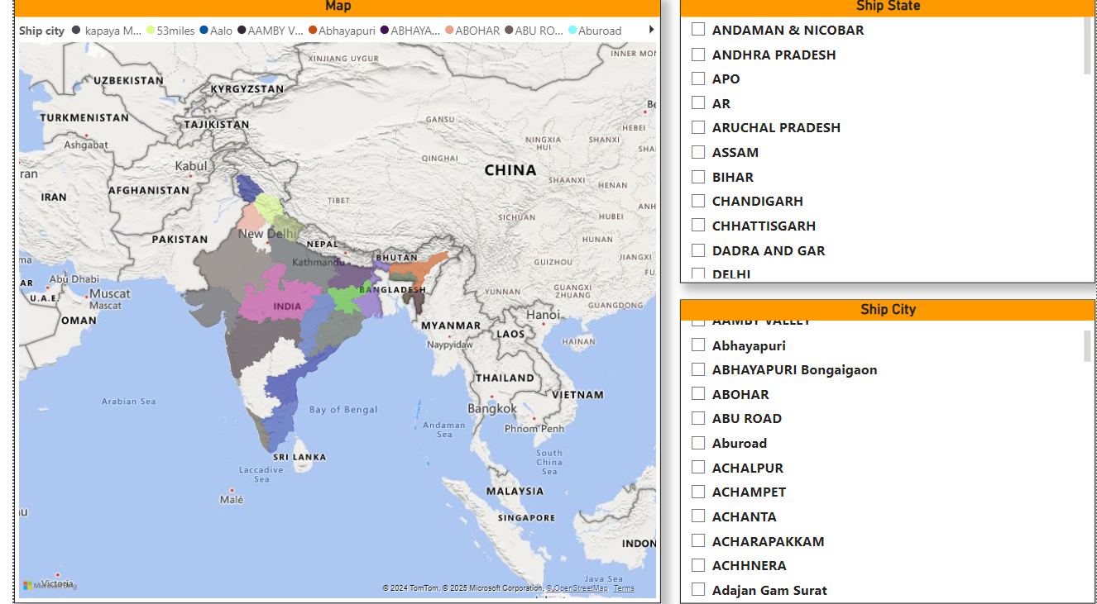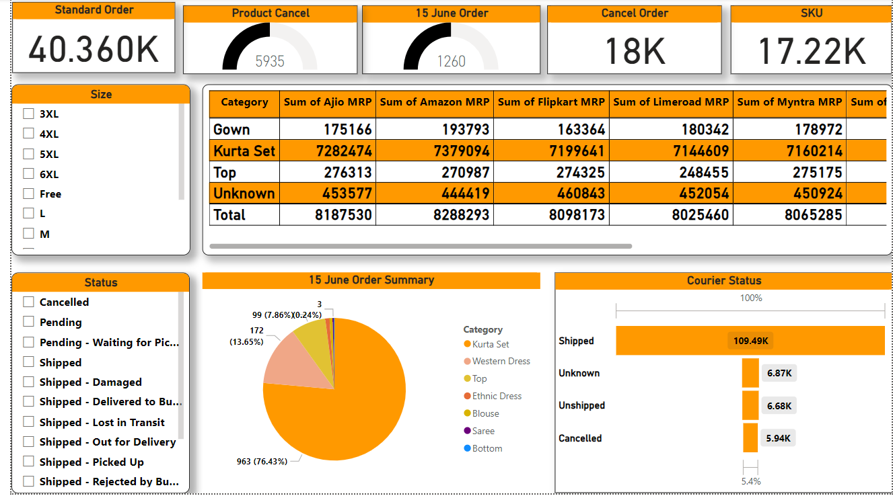

**CHAPTER -5**

### ****Key Insights and Analysis****

In this chapter, we present the major insights and findings derived from the analysis of Amazon's sales data using Power BI. These insights provide valuable information about customer behavior, product performance, regional sales, and more. By visualizing the data, we are able to uncover trends, highlight best-performing products, identify areas of improvement, and offer actionable recommendations for driving business growth.

#### ****1. Trends in Sales Over Time****

One of the key insights from the analysis is the identification of significant trends in sales performance over time. Using line charts and time-based visuals, we observed the following:

* **Seasonal Sales Spikes:** Amazon experienced significant spikes in sales during peak shopping periods such as **Black Friday**, **Cyber Monday**, and **Prime Day**. These spikes align with consumer behavior and holiday promotions, suggesting that strategic campaigns and discounts during these periods are highly effective.
* **Steady Growth:** Over the analyzed period, there was a steady upward trend in sales, indicating that Amazon’s overall performance is improving year-on-year. This suggests that the company’s sales strategies are yielding positive results.
* **Monthly Fluctuations:** Sales data revealed that certain months experience lower revenue, which could be related to seasonal purchasing behavior. For instance, post-holiday months tend to show a dip in sales, and targeted marketing during these periods could help maintain revenue flow.

**Recommendation:** Focus on maintaining strong promotional activities and discounts during key holiday seasons, while also considering off-season strategies to boost sales during slower months.

#### ****2. Best-Selling Products or Categories****

By analyzing product performance, the project revealed which products and categories contributed the most to overall revenue:

* **Electronics and Fashion Lead Sales:** The **Electronics** and **Fashion** categories were the top performers in terms of sales revenue, accounting for the majority of total sales. Subcategories such as **smartphones**, **laptops**, and **clothing** showed strong demand.
* **Top Products:** Specific products like the **latest iPhone models** and **popular fashion accessories** had the highest sales volumes. These products were consistently in demand, contributing significantly to Amazon’s overall sales.

**Recommendation:** Focus on optimizing inventory for top-selling electronics and fashion items. Additionally, consider launching targeted marketing campaigns for these high-demand products to maintain a competitive edge.

#### ****3. Regional Sales Performance****

The analysis of regional data revealed how sales performance varied across different geographic areas:

* **Urban Areas Outperform Rural Areas:** Sales in urban regions significantly outperformed rural areas, indicating that urban consumers have higher purchasing power and more access to online shopping.
* **Region-Specific Trends:** Certain regions showed high demand for specific product categories. For example, **electronics** were popular in metropolitan areas, while **home goods** saw more sales in suburban regions.

**Recommendation:** Tailor marketing campaigns and promotions based on regional preferences. For instance, increase electronics-related promotions in urban areas while focusing on home goods in suburban regions.

#### ****4. Customer Segmentation Insights****

Customer demographics and purchasing patterns played a key role in understanding sales performance. The analysis identified the following:

* **Age Group Insights:** The **25-34 age group** emerged as the largest customer base for Amazon, with a significant proportion of these customers purchasing electronics and fashion products.
* **Urban vs. Rural:** Urban customers were more likely to make frequent online purchases, particularly in high-demand categories like electronics. In contrast, rural areas showed more interest in everyday products and home goods.

**Recommendation:** Consider segmenting marketing strategies to cater to different customer age groups and regions. For instance, creating targeted ads for young adults (25-34 years) featuring trending electronics and fashion items could drive more conversions.

#### ****5. Profit Margins and KPIs****

Key performance indicators (KPIs) such as profit margins, average order value, and return on investment were critical for evaluating Amazon’s profitability:

* **Profit Margins by Category:** Electronics had higher profit margins compared to categories like books or clothing. While electronics saw higher sales, their profit margins were impacted by the high cost of goods sold.
* **Average Order Value:** The average order value (AOV) increased significantly during holiday sales, particularly for bundled products or high-ticket items.

**Recommendation:** Focus on optimizing profit margins for lower-performing categories while maintaining the high margins for electronics. Offering product bundles or discounts on high-ticket items during peak sales periods could drive higher order values.

**CHAPTER -6**

### ****Challenges and Solutions****

In any data analysis project, challenges are inevitable, and overcoming them is crucial to achieving meaningful insights. This chapter discusses the key challenges faced during the Amazon sales analysis project, the strategies employed to resolve them, and the lessons learned from these experiences.

#### ****1. Data Quality and Inconsistencies****

**Challenge:**  
The first challenge encountered during the project was the **quality and consistency** of the dataset. The raw data contained missing values, duplicates, and incorrect formatting, which made it difficult to perform reliable analysis.

* **Missing Data:** Some product categories had missing sales figures, especially for certain months or regions.
* **Duplicate Entries:** There were duplicate records for some orders due to system errors in data collection.
* **Inconsistent Formatting:** Some columns contained inconsistent date formats and currency symbols, leading to discrepancies in the analysis.

**Solution:**  
To resolve these issues, the following steps were taken:

* **Data Cleaning:** We used Power Query in Power BI to handle missing values by filling them with appropriate default values or removing the rows where necessary. Duplicates were removed through deduplication techniques, ensuring that only unique records were considered in the analysis.
* **Standardizing Formats:** Data formats, particularly dates and currency values, were standardized across the entire dataset using Power Query’s transformation tools. We also ensured that all product categories followed a uniform naming convention.

**Key Learning:**  
It is essential to ensure that data is clean and consistent before starting any analysis. Without proper data preparation, the results can be misleading, and additional time is required to address issues during analysis.

#### ****2. Complex Relationships Between Data Tables****

**Challenge:**  
Another challenge was establishing clear relationships between different tables in the dataset. The dataset consisted of multiple tables such as **Products**, **Sales Transactions**, and **Customer Information**, and defining the right relationships was key to ensuring accurate analysis.

* **Many-to-Many Relationships:** Some tables had many-to-many relationships, leading to issues like data duplication or missing relationships in the Power BI model.
* **Missing Keys:** Certain fields like **Product ID** were inconsistent across tables, leading to problems while trying to establish relationships between sales transactions and product categories.
* **Diagrams representing data models and relationships between tables:**

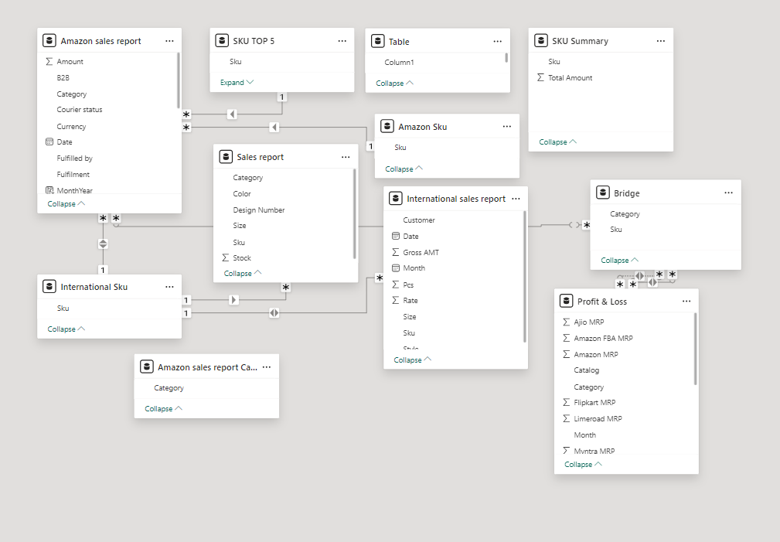

**Solution:**  
To overcome these issues, we took the following steps:

* **Star Schema Modeling:** We implemented a star schema design, where the sales transaction table acted as the fact table, and the product and customer tables were dimension tables. This helped in simplifying the relationships and avoiding complexity.
* **Data Mapping and Data Cleansing:** We ensured all missing keys were identified and corrected. We used DAX functions to create calculated columns that could better link the data, making the relationships more reliable and precise.

**Key Learning:**  
Proper data modeling is critical for ensuring that relationships between tables are accurate and meaningful. Complex relationships should be simplified to enhance the model’s efficiency and reduce potential errors.

#### ****3. Performance and Processing Speed****

**Challenge:**  
As the dataset grew in size, processing and visualizing large amounts of data began to impact Power BI’s performance. The dashboard took longer to load and refresh, particularly when dealing with millions of rows of sales data.

**Solution:**  
To resolve performance issues, several optimization techniques were employed:

* **Aggregating Data:** We aggregated data at a higher level (e.g., daily or weekly sales) to reduce the overall size of the dataset being processed. This helped in improving the processing time without compromising the granularity of the insights.
* **Data Reduction:** We filtered out irrelevant data points such as transactions from years outside the scope of the analysis and regions that were not part of the focus.
* **Optimizing Visuals:** We used fewer complex visuals like high-cardinality charts, focusing on simpler, more efficient visualizations like bar charts and line graphs, which allowed faster performance without losing critical insights.

**Key Learning:**  
Optimizing large datasets for performance is crucial, especially in Power BI, where visualizations can slow down the system if the data model isn’t efficient. Aggregating data and simplifying visuals can greatly improve the user experience.

#### ****4. User Interactivity and Dashboard Usability****

**Challenge:**  
Creating a dashboard that was both **interactive** and **user-friendly** posed its own challenges. Initially, the dashboard had too many visuals that caused user confusion and made navigation difficult.

**Solution:**  
To improve interactivity and usability, the following changes were made:

* **Use of Filters and Slicers:** Interactive slicers were added to allow users to filter data by regions, categories, and time periods. This made the dashboard more dynamic and gave users the ability to drill down into specific data points.
* **Clear and Concise Visuals:** The dashboard was redesigned to have a cleaner layout with only essential visuals that directly conveyed the insights. Unnecessary elements were removed to ensure that the dashboard was easy to navigate.
* **Tooltips and Explanations:** Tooltips were added to explain what each visualization represented, which helped users understand the data context without requiring additional training.

**Key Learning:**  
Creating an interactive and user-friendly dashboard is key to ensuring that the analysis is actionable. User-centric design improves the overall value of the dashboard, making it an effective decision-making tool.

#### ****5. Data Integration and Real-Time Reporting****

**Challenge:**  
Integrating **real-time sales data** into the analysis was a challenge, as the dataset initially provided did not include up-to-the-minute transactional data.

**Solution:**  
We explored integrating **live data feeds** from Amazon sales APIs or other third-party services to bring real-time sales data into Power BI. However, due to project limitations, we focused on preparing the model for future integration by structuring it to accommodate real-time data in the future.

**Key Learning:**  
For future projects, integrating real-time data is essential to providing up-to-the-minute insights. While not implemented in this project, preparing the data model in advance ensures that real-time data can be added seamlessly.

### ****Chapter -7****

**Future Scope**

This chapter outlines the potential areas where the current Amazon Sales Analysis project can be expanded, providing a roadmap for future improvements and enhancements. These enhancements could involve integrating additional data, introducing advanced analytical techniques, or exploring new technologies to refine and further optimize business decisions.

**1. Expanding the Analysis with Predictive Analytics**

While the current analysis offers valuable insights into historical sales patterns, incorporating **predictive analytics** could enhance decision-making by forecasting future sales trends, customer behavior, and demand fluctuations. By applying machine learning algorithms such as **time series analysis** or **regression models**, Amazon could predict:

* **Future sales trends**: Forecasting sales for upcoming seasons or months, allowing Amazon to better prepare for demand surges and adjust inventory levels accordingly.
* **Customer buying behavior**: Predicting which products are likely to see an increase in sales based on historical data, customer preferences, and external factors like marketing campaigns or social trends.
* **Pricing strategy optimization**: Predicting how changes in pricing might impact sales, which would enable more effective pricing strategies.

Implementing these predictive models will enable Amazon to make proactive business decisions rather than reactive ones, helping to further improve profitability and customer satisfaction.

**2. Integration of Real-Time Data**

Currently, the analysis relies on historical sales data, but integrating **real-time data** into the dashboard could greatly improve the responsiveness of Amazon's decision-making. By incorporating data such as:

* **Live sales data**: Tracking ongoing sales in real-time to identify trends and adjust marketing or sales strategies quickly.
* **Customer activity data**: Monitoring customer interactions with products (e.g., click-through rates, time spent on product pages) in real-time to adjust recommendations or offers.
* **Supply chain and logistics data**: Integrating live data on inventory levels, shipping statuses, and delivery tracking could enable better coordination between sales and supply chain teams, reducing delays and improving customer satisfaction.

Real-time data integration would provide Amazon with an up-to-the-minute view of their operations, allowing for quicker adjustments and more agile decision-making.

**3. Incorporating Additional Datasets**

To gain deeper insights into Amazon’s business performance, it would be beneficial to integrate **additional datasets**. These datasets could include:

* **Customer Feedback and Reviews**: Analyzing customer reviews and feedback can provide insights into product quality, customer satisfaction, and areas for improvement. Sentiment analysis on customer reviews could also be incorporated to better understand consumer sentiment and inform product development and marketing strategies.
* **Marketing Campaign Data**: Incorporating data on past marketing campaigns (e.g., email marketing, social media ads, discounts) could help assess the effectiveness of these initiatives in driving sales, allowing Amazon to optimize its future campaigns for better results.
* **Competitor Data**: Data on competitors’ sales and marketing strategies can provide a benchmarking framework, helping Amazon to better understand its market position and adjust strategies to maintain its competitive edge.

By combining these additional datasets, Amazon can develop a more comprehensive view of its business, incorporating external factors and customer feedback into the decision-making process.

**4. Enhancing Customer Segmentation**

The analysis currently segments customers by region and age group. However, further segmentation could reveal additional opportunities for personalized marketing and product recommendations. Some areas to explore include:

* **Behavioral Segmentation**: Analyzing customer purchase patterns, browsing history, and preferences to create highly targeted customer profiles. This would allow Amazon to personalize product recommendations and promotional offers even further.
* **Geographic Segmentation**: Diving deeper into regional or even hyper-local trends could help Amazon offer location-based promotions, inventory adjustments, or shipping strategies to optimize sales and customer satisfaction.
* **Lifetime Value (LTV) Segmentation**: Identifying high-value customers based on their long-term spending behavior can help Amazon focus marketing efforts on retaining profitable customers through loyalty programs or exclusive offers.

By enhancing customer segmentation, Amazon can deliver more tailored shopping experiences, leading to increased conversion rates and customer loyalty.

**5. Exploring Advanced Data Visualization Techniques**

While the current Power BI dashboard provides valuable insights, incorporating **advanced data visualization techniques** could further enhance the ability to interpret and present data effectively. These techniques might include:

* **Geospatial Mapping**: Using geographical data visualization (such as heatmaps or interactive maps) to understand regional sales performance and customer distribution more clearly.
* **Advanced KPI Dashboards**: Creating more sophisticated Key Performance Indicator (KPI) dashboards with drill-through capabilities to explore performance by time periods, regions, and product categories in greater detail.
* **Interactive Scenario Planning**: Implementing interactive “what-if” analysis tools, where users can manipulate variables (such as pricing, advertising spend, or inventory levels) to assess the potential impact on sales and revenue.

Advanced visualization techniques would enable decision-makers to explore data more dynamically, uncovering hidden patterns and gaining deeper insights.

**Conclusion and Recommendations**

**Conclusion:**

1**. Kurta Set** is the top-performing category, driving the majority of sales.

2. **Bengaluru** is the most frequently shipped-to city, showing strong demand.

3. The top 5 SKUs contribute significantly to total revenue.

4. Promotions boost sales for specific categories like **Kurta Set and Western Dress.**

5. Logistics need improvement, with **18K cancelled orders** and some damaged shipments.

**Recommendations:**

1. Focus on top-selling categories like Kurta Sets to maximize revenue.

2. Strengthen the supply chain in Bengaluru to meet high demand.

3. Expand promotional strategies to underperforming categories for better sales.

4. Address logistics issues to reduce cancelled and damaged orders.

5. Optimize inventory for the top 5 SKUs to prevent stockouts and ensure availability.

**References**

• **Dataset Source**:

"Amazon Sales Data" – Publicly available dataset or simulated data based on typical e-commerce transactions.

• **Tools and Tutorials**:

Power BI Documentation: <https://powerbi.microsoft.com/>

DAX Formulas Reference: <https://learn.microsoft.com/en-us/dax/>

• **Learning Resources**:

"Power BI for Data Visualization" – LinkedIn Learning.

"Data Cleaning and Transformation Techniques" – Microsoft Learn.

• **Inspirational Sources**:

E-commerce Analytics Best Practices – Blogs from Tableau, Power BI, and Kaggle.